Name: Abrha Gebreslassie, Berhe

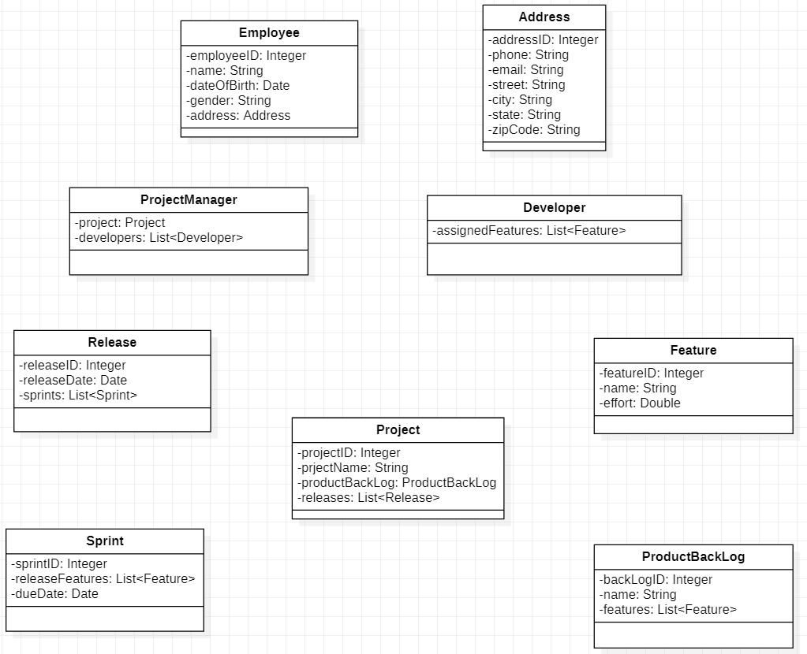Subject: Lab Assignment -1